General course description

The course consists of six seminars, where we alternate between reading about how to write a thesis, reading sections from published Masters’ theses, and iteratively writing sections of a thesis plan.

This is the general outline for the seminars in the course:

Seminar | Read in published thesis | Write | Additional reading
1 | Introduction, Background,  Theory,  Method |  | - Checklist  - Instructions for theses  - On academic writing
2 |  | Introduction,  Background | - Theme-specific papers  - Group members’ thesis introductions
Feedback session on research questions

3 |  | Related work | - Literature related to your thesis' subject area  - Group members’ theses
4 | Results, Discussion,  Conclusion |  | - Papers on assessing the wider effects of IT systems
5 |  | Time plan, final submission | - Group members’ theses

Also, the course includes five live lectures on the following topics:

Lecture | Topic | Prepares for seminar
1 | Course introduction | 1-2
2 | Information search and evaluation | 3
3 | Introduction to academic writing in English | 2,3,5
4 | Research Methods | 3-5
5 | Feedback on language and grammar | 5

You will be divided in topic groups, where all students in each group will have a common denominator such as the topic area or general method that will likely be employed in the thesis.

In preparation for each seminar, you will work individually or in pairs, depending on whether you have someone else to write a thesis introduction with during the course, and answer questions in preparation to the seminars. Each WebReg “subgroup” (pair or individual) A1-1 through D5-5 will make contributions that address the questions before each seminar.

For each seminar, there will be reading material specific to the seminar. Reading material pertaining to earlier seminars will be used at later seminars as well. Also, you may need to read more material than explicitly stated for the course in order to produce a good text (i.e., passing the course). The reading requirements listed should not be interpreted as an upper bound on the number of references required for a passing grade in the course.

For all seminars where you read sections from a published thesis, all students in the same group read the same thesis, from the ones listed in the section Masters’ theses below.

For all seminars where you read sections from each other's reports, make sure to provide enough detail in your feedback that your friends will be able to address the concerns you have. Be constructive and write the kind of feedback you would want from your peers!

Those who write theses in pairs are still required to provide feedback individually on other theses.

Note: You will need to make all submissions in the course in English.

Discussions during seminars

To support discussions during seminars, each individual must bring electronic or physical copies of all items on the reading list pertaining to each seminar, along with answers to the seminar-specific questions. Smartphones are not allowed as a medium for accessing electronic copies as they are difficult to share and use efficiently during seminars. Also, each individual must be able to take notes of feedback given during the seminar, meaning either pen and paper or a laptop/tablet is required.

As you discuss and compare answers to questions during the seminars, you may feel a little pressed for time. Start each seminar with an initial round of questions on what you felt was most difficult in assessing or matters that you have struggled to understand. Make sure that everyone gets to express their main gripes with thesis writing at this stage. Then, divide the time given by your seminar leader evenly among yourselves, focusing on the issues that most group members thought important to discuss. It is ok if you do not get to review all questions during seminars, but everyone should feel that the time is well spent and that all submissions have been reviewed. Take help from your seminar leader if you wish to understand how to interpret questions or instructions.

Make the seminars valuable for yourselves. All your answers need to be justified, and you need to take into account the literature available when assessing submissions during the course. That way, you will be able to make the most out of the course.

Using LISAM

In LISAM, the course has a “collaborative workspace” (see next page) where each group has a folder for each seminar where you can upload material. To simplify finding documents during the course, here is a suggested standard way of naming documents:

- When writing answers to texts that you are reading during the course, you simply upload your answers in the folder pertaining to the seminar, with a file name LiU-ID_seminar_1.pdf.
- When writing parts of your thesis plans, you create a folder for each pair of students for the respective seminar, upload your texts in that folder and upload your comments in the folders pertaining to other students’ texts with descriptive names of all files that you upload. As an example, if students with LiU-ID:s X and Y work together in team A1, they go to the folder “Groups - Group A1 - Seminar 2” and they create a folder X_Y where they upload their manuscript, aptly named X_Y_thesis_plan_seminar_2.pdf or similar. Then, their team mates Z and W upload their reviews of the text written by X & Y in the same X_Y folder, but they name their files Z_review_of_X_Y_seminar1.pdf and W_review_of_X_Y_seminar1.pdf, respectively.
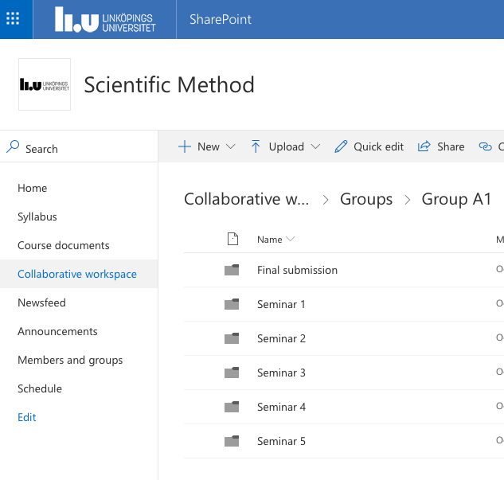

Passing requirements
For each seminar, you are required to do the preparations for the seminar according to the instructions and participate actively in discussions during the seminar.

Preparations for seminars:

- For the writing seminars (2, 3 & 5): Each pair is required to upload their common submission, and each student is required to upload reviews of others’ submissions.
- For the reading seminars (1 & 4): Each pair is required to upload answers to common questions pertaining to the seminar. Your answers need to be properly justified by referring to the material that you have read.

Plagiarism or copyright: Plagiarism or copyright violations are strictly forbidden. You are not allowed to self-plagiarize work submissions in other courses. See the LiU self-study guide on Plagiarism for more information. Cases of plagiarism will be filed with the Disciplinary Board.

Attendance: If you are unable to attend a seminar, you will need to inform your seminar leader in advance and
- interview at least two members from your group on what you discussed during the seminar, and
- submit a written reflection of 1-2 A4 pages on the outcome of the seminar discussions and joint conclusions to your seminar leader one week after the missed seminar at the latest.

Masters’ theses

Masters’ theses pertain to the groups’ topics. Each thesis has a number of keywords describing it, and student groups are formed based on the similarity of the thesis proposals submitted by students and the topics of these theses.
- Case study, development processes: ”Vertically Scaling Agile: A Multiple-Case Study” by Nicklas Östman & Rasmus Lindström, Linköpings universitet 2017.
- FPGA development: “SEU Mitigation Techniques for Advanced Reprogrammable FPGA in Space” by Fredrik Brosser and Emil Milh, Chalmers 2014
- Usability study, iterative development: “Usability of a Business Software Solution for Financial Follow-up Information of Service Contracts” by Therese Borg, Linköpings universitet, 2018
- Theoretical computer science, algorithm construction: “Upper Bounds on the Time Complexity of Temporal CSPs” by Peter Stockman, Linköpings universitet 2016
- Experimentation, Machine Learning: “Organ detection and localization in Radiological Image Volumes” by Tova Linder and Ola Jigin, Linköpings universitet 2017
- Security evaluation: “Certificate Transparency in Theory and Practice” by Josef Gustafsson, Linköpings universitet 2016

